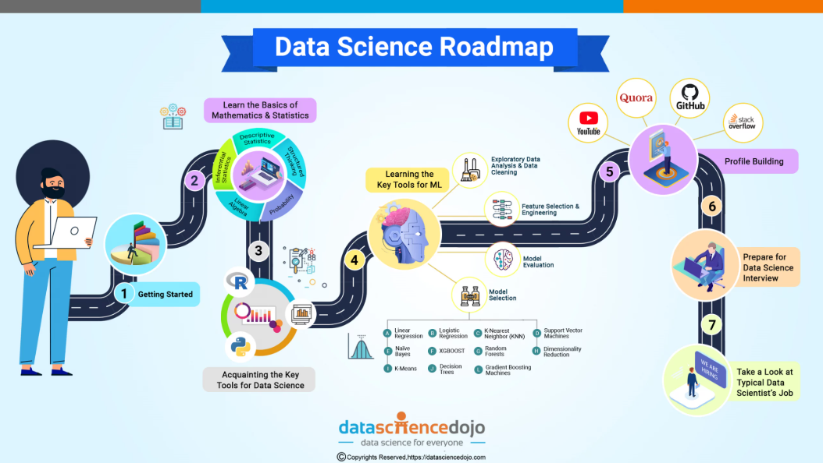

**MY LEARNING JOURNEY IN CERTIFICATE IN INTRODUCITON TO DATA SCIENCE (Alison University).**

**Roadmap from Beginner to Advanced**

**MODULE 1**

**Introduction**

This blog post is a reflection and structured teaching guide based on my learning experience with **Module 1** of Alison’s *Certificate in Introduction to Data Science*. It is written for beginners and aspiring data scientists who want a clear, actionable overview of core concepts in data science.

Whether you’re an educator, student, or self-learner, this article is designed to help you understand the **fundamentals of data science**, including theoretical frameworks, machine learning workflows, and model evaluation techniques.

The following content is not only a personal learning archive but also a teaching tool for educators, tutors, and mentors introducing data science concepts to others. (From Basics to Advanced as we will continue in other documentations).

**QN. What is Data Science?**

Data Science is the process of extracting actionable knowledge from structured and unstructured data using scientific methods. It combines multiple disciplines to derive insights and support intelligent decisions. The core areas contributing to data science include:

* Mathematics and Statistics
* Computer Science
* Business Intelligence and Domain Knowledge
* Communication and Data Visualization

Data scientists work at the intersection of these domains to solve real-world problems through data analysis and modeling.

**1. Types of Analytics**

Understanding the different types of analytics is essential for identifying the purpose of a data project:

* Descriptive Analytics — Describes historical data: *What happened?*
* Diagnostic Analytics — Examines cause-effect: *Why did it happen?*
* Predictive Analytics — Forecasts future outcomes: *What is likely to happen?*
* Prescriptive Analytics — Suggests actions: *What should be done?*
* Real-Time Analytics — Monitors live data for immediate decisions
* Retrospective Analytics — Analyzes long-term trends from past data

Each type plays a critical role in business intelligence and strategy.

**2. The Data Science Process**

During my training, I encountered several frameworks that structure the data science lifecycle. These models provide repeatable steps for solving data-driven problems:

**KDD Process (Knowledge Discovery in Databases)**

1. Selection
2. Preprocessing
3. Transformation
4. Data Mining
5. Evaluation

**CRISP-DM (Cross Industry Standard Process for Data Mining)**

1. Business Understanding
2. Data Understanding
3. Data Preparation
4. Modeling
5. Evaluation
6. Deployment

**CCC Big Data Pipeline**

An industry-scale pipeline designed for big data handling:

* Data Collection → Preparation → Analysis → Visualization → Decision-Making

**Modern Python-Based Pipeline**

Reflecting practical workflows:

* Data Ingestion (via APIs, databases)
* Data Cleaning and Transformation
* Feature Engineering
* Model Building using Machine Learning
* Model Evaluation
* Deployment through APIs or cloud platforms

**3. Big Data Fundamentals**

Big Data refers to data that is too large, fast, or diverse to process using traditional methods. Key attributes are known as the 3Vs:

* Volume — Scale of data
* Velocity — Speed of data generation
* Variety — Range of data types (structured, unstructured)

Tools such as Hadoop, Apache Spark, and NoSQL databases (e.g., MongoDB, Cassandra) enable scalable big data analytics and processing.

**4. Introduction to Machine Learning**

Machine Learning (ML) is a subset of artificial intelligence that allows systems to learn patterns from data and make predictions or decisions without being explicitly programmed.

Three primary learning paradigms:

* Supervised Learning — Learns from labeled data
* Unsupervised Learning — Discovers patterns in unlabeled data
* Reinforcement Learning — Learns by interacting with an environment through trial and error

**5. Supervised Learning**

Supervised learning involves mapping inputs (features) to known outputs (labels). It includes:

**Classification**

Predicts discrete classes or categories.  
 Examples: spam detection, medical diagnosis, credit risk analysis.

**Regression**

Predicts continuous numeric values.  
 Examples: house price prediction, temperature forecasting.

Key algorithms:

* Logistic Regression
* Decision Trees
* Random Forest
* Support Vector Machines (SVM)
* Naive Bayes
* Neural Networks

**6. Unsupervised Learning**

This learning method is used when the dataset lacks labeled outputs. The objective is to uncover hidden patterns or structure.

**Clustering**

Groups data based on similarity.  
 Examples: customer segmentation, anomaly detection.

Common algorithms:

* K-Means
* Hierarchical Clustering
* DBSCAN

**Dimensionality Reduction**

Simplifies data by reducing features while retaining structure.  
 Techniques: Principal Component Analysis (PCA), t-SNE.

**7. Statistical Learning Theory**

Statistical learning theory underpins the mathematics behind many machine learning models. It focuses on the relationship between model complexity and performance.

Core elements:

* Input (x): Features
* Output (y): True labels
* Hypothesis (h): Model function
* Loss Function (ℓ): Error measurement
* Empirical Risk: Average loss on training data
* Expected Risk: Generalization error on unseen data

A key principle: Occam’s Razor — simpler models are preferred when they perform comparably to complex ones.

**8. Model Evaluation**

Evaluating a machine learning model requires metrics that measure both accuracy and reliability.

Common metrics:

* Accuracy = Correct predictions / Total predictions
* Precision = TP / (TP + FP)
* Recall = TP / (TP + FN)
* F1 Score = 2 * (Precision * Recall) / (Precision + Recall)

Overfitting: The model learns noise instead of patterns — excellent training performance but poor generalization.  
 Underfitting: The model is too simple to capture the patterns in data — poor performance on both training and new data.

**9. Model Building and Deployment**

The end-to-end workflow for machine learning model deployment:

1. Data Collection
2. Data Cleaning and Integration
3. Feature Engineering
4. Model Training
5. Model Evaluation
6. Deployment and Monitoring

Application scenarios:

* Sentiment analysis
* Recommender systems
* Price forecasting
* Fraud detection

**10. Azure Machine Learning Studio**

Though not explored in-depth during the module, Azure ML Studio was mentioned as a practical cloud platform for building models visually. Features include:

* Drag-and-drop interface for workflows
* Dataset uploading and exploration
* Pre-built models and custom training modules
* Deployment of models as REST APIs
* Integrated evaluation dashboards

I intend to explore this tool further for real-world projects.

**ROADMAP OF KEY CONCEPTS**

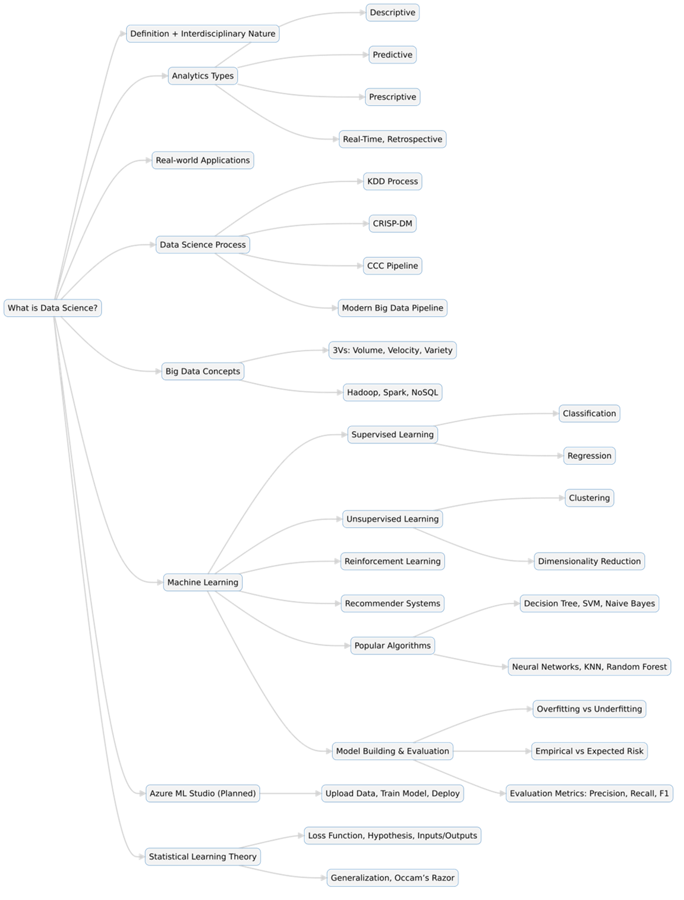

**Conclusion**

Through Alison’s Certificate in Introduction to Data Science, I acquired structured knowledge and practical insights into the core of data science. This includes understanding data processes, learning the mechanics of machine learning, exploring big data ecosystems, and interpreting model performance.

This roadmap serves both as a foundation for continued learning and a guide for anyone seeking to enter the field of data science. I hope it provides clarity and direction for fellow learners, educators, and professionals on the same journey.

See you in the next Module 😉